Electrical Systems National, Domestic, and IoT Device

Edirimanna Y.H.
E/20/089
1. Sri Lankan Electricity System
1.1 How Power Is Generated and Transmitted to Houses
Sri Lanka uses mainly 3 methods:
- Hydropower (Mahaweli reservoirs and other major dams)
- Thermal power (coal at Norochcholai, diesel and furnace oil plants)
- Renewables (solar farms, rooftop solar, wind)
Step-by-step flow:
- Generation
Power is produced at power plants (11 kV–15 kV for most hydros, much higher for thermal stations).
- Step-up transformation
Voltage is increased using step-up transformers to 132 kV, 220 kV, or 400 kV for efficient long-distance transmission.
- Transmission
High-voltage AC lines carry energy across the country via the CEB national transmission grid.
- Step-down at Grid Substations
Voltage is reduced to 33 kV or 11 kV at primary substations.
- Distribution
Local substations further reduce voltage to 400/230 V for homes.
- Supply to Houses
Final delivery uses service drops, meters, MCBs, and consumer wiring.
1.2 Voltages Used
- 400 V (three-phase) → Line-to-line
- 230 V (single-phase) → Line-to-neutral
- 50 Hz frequency (standard)
- High-voltage lines: 132 kV, 220 kV, and sometimes 400 kV

2. Electrical System in a House
2.1 Wiring
A typical house uses:
- Single-phase 230 V supply
- Main components:
  - Service cable
  - Energy meter
  - Main breaker (MCB)
  - Residual Current Device (RCD) / RCCB
  - Distribution board with separate circuits
Circuit types:
- Lighting circuits (1–1.5 mm² wires)
- Socket/outlet circuits (2.5 mm² wires)
- High-load appliances (air conditioners, heaters, ovens) may use dedicated breakers and 4–6 mm² cables
Color coding :
- Live – Brown
- Neutral – Blue
- Earth – Green/Yellow
2.2 Protection
Protection ensures safety against fire and electrocution:
- Main MCB – protects against short circuits/overload
- RCD / RCCB – protects against electric shock by monitoring leakage currents
- Earthing – diverts fault current safely into the ground
- Surge protectors – protect against lightning and grid surges

3. Electrical System for an IoT Device
3.1 Wiring
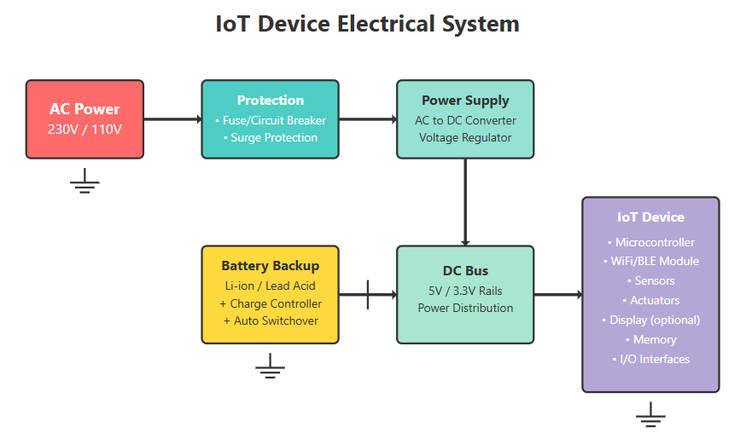
- Clear power flow from AC input through all components
- Ground connections for safety
- DC distribution bus to power all IoT components
3.2 Protection
IoT devices are sensitive, so basic protection is essential:
- Fuse– prevents overcurrent
- TVS diode – protects against voltage spikes
- Reverse-polarity protection – using a diode or MOSFET
- Voltage regulator – ensures stable voltage
- ESD protection – for sensors and communication pins
3.3. Backup Power:
- Battery system with charge controller
- Automatic switchover when main power fails
- Keeps the IoT device running during power outages

